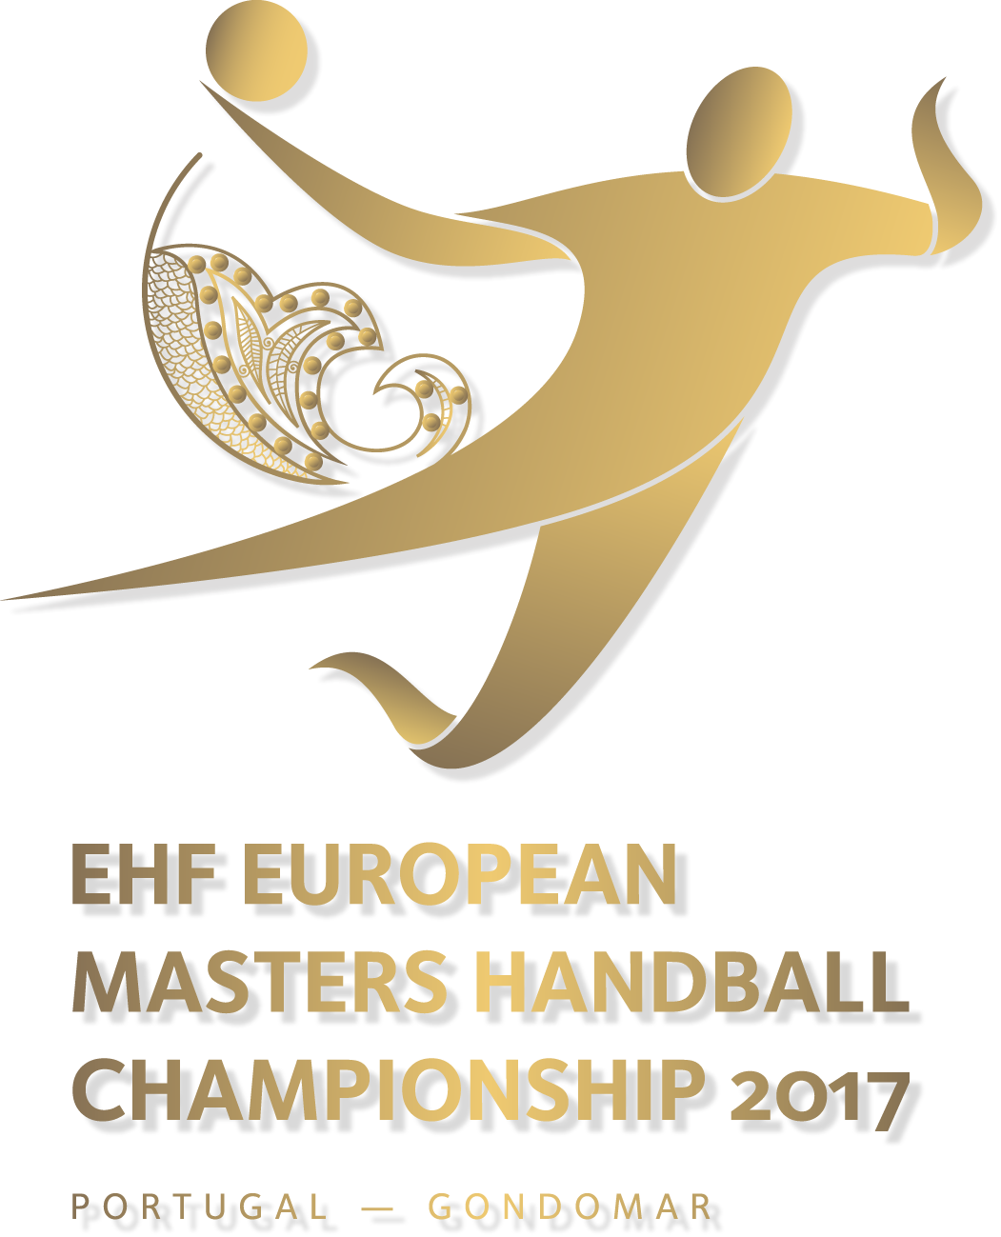
Registration Form

2017 European Masters Handball Championships
June 08 - 11, 2017 / GONDOMAR – Portugal

Please note: Each team has to pay a deposit payment of € 600 to the EHF.
€ 500 will be refunded in case of participation in the 2017 Masters EChs.
Registrations only valid in connection with bank remittance!

General data
Please fill in (capital letters) or mark correctly!

team name | country | no. of players | no. of referees | no. of welcome dinner participants

name of team responsible | address
phone | ZIP code
mobile | city
email | country
Age Category
Age check of players will be done by presenting an internationally valid passport at the venue! No extraordinary playing permissions will be granted! Health confirmation requested - to be presented by the accreditation.

Men 35+  (born before  31.12.1982) | Men 45+  (born before  31.12.1972) | Men 50+  (born before  31.12.1967) | Women 33+  (born before 31.12.1984) | Women 43+  (born before  31.12.1974)
□ | □ | □ | □ | □

Confirmation
National Federation:

Date & Signature:

Please complete this form and return it to the EHF (brantl@eurohandball.com / fax: +43 1 80 151 138) by
10.04.2017 at the latest.

